Beamsplitter

Beamsplitter Sample
We demonstrated the performance used in the beamsplitter polarity design trade-off study, (See Appendix 5.6). We bought a sample from Lumonics Optical, Nepean, Ontario.

Design Specifications
Specifications for Sample Beam Splitter, Altair
Reflection Band | 0.4 - 0.835 | micron
Average Reflectance | > 95% | (Weighted Average over Entire band. Note 1,2)
Reflectance 0.592 ± 0.002 micron | >90% | (dropout not allowed here. Note 3)
Transmit Band | 0.835 - 2.4 | micron
 | 0.835 - 2.5 | micron (secondary goal)
Min. Throughput | > 96% | (Worst case over Entire Band Note 4)
Transmit Sub-bands
Avg. Transmission |  | (Averaged over sub-band)
J 1.1 - 1.4 micron | >97% | Requirement
H 1.5 - 1.8 micron | >97% | Requirement
K 2.0 - 2.4 micron | >97% | Requirement
K 2.0 - 2.4 micron | >99% | Strong Goal
Cuton region | monotonic | Goal. Note 5
Location | <0.835 | micron
Polarization | any | maximixe throughput for all polarization
Angle of Incidence | 15° | Deg
Diameter | 25 ± 1 | mm
Material | Infrasil
Thickness | 18 + /-0.25 | mm
Transmitted Wavefront Error | <1/10 wave @ 630 nm | over 80 % of diameter
Reflected Wavefront Error | <1/10 wave @ 630 nm | over 80 % of diameter
Finish | 20 -10
Wedge | 15 + /-3 | arcminutes
Chamfer | 0.7 | mm @ 45° deg
Table 4.8

Notes

The intent is to maximize the overall transmission and reflection of the beamsplitter. Since the reflected star light is detected on a CCD, whose efficiency decreases at the extremes of the reflection band, a bandpass which emphasizes the middle wavelengths is acceptable. The product of stellar continuum and CCD curves is given by:
a + bλ + cλ² + dλ³ where a=-6.512, b=25.925, c=-25.911, d=6.039
For example, a filter which rises linearly from 0 to 99% reflection from 0.4 to 0.45 μm, is flat to 0.8 μm, and then falls to 4% at 0.835 μm meets our specification for average throughput when weighted by the above cubic. Yet it only passes 90.6% of a rectangular bandpass from 0.4 to 0.835 μm.

Figure 4.25
Product of stellar and CCD curves. Weighting function for averaging bandpass throughput.

Figure 4.26
Representative Filter design.

2. Dropouts in the reflection band are allowed in general, provided that the coating meets the specification for throughput averaged over the required band.

3. Exception for allowable dropouts: The beamsplitter must reflect sodium resonance lines with good efficiency to preserve an upgrade path for artificial laser guide stars.

4. Dropouts, below the minimum transmitted throughput, are not acceptable. Transmitted ripple is a free parameter to maximize average throughput in each sub-band. The goal is to transmit every photon longward of 0.835 μm, with the highest efficiency practical. In particular, efficiency in the K sub-band pays dividends in reduced emissivity as well as throughput.

5. Sharpness of cuton and cutoff of the reflection band is a free parameter to maximize weighted average reflection efficiency.

6. All specifications include dichroic, substrate and anti-reflection coating on back surface.

Measured Performance Curves
The following graphs show the measured transmission of the 25 mm diameter beamsplitter sample, from 400 nm to 2500 nm. The transmission of the anti-reflection coated back surface is included. Note that the reflection efficiency in the visible band is >99%.

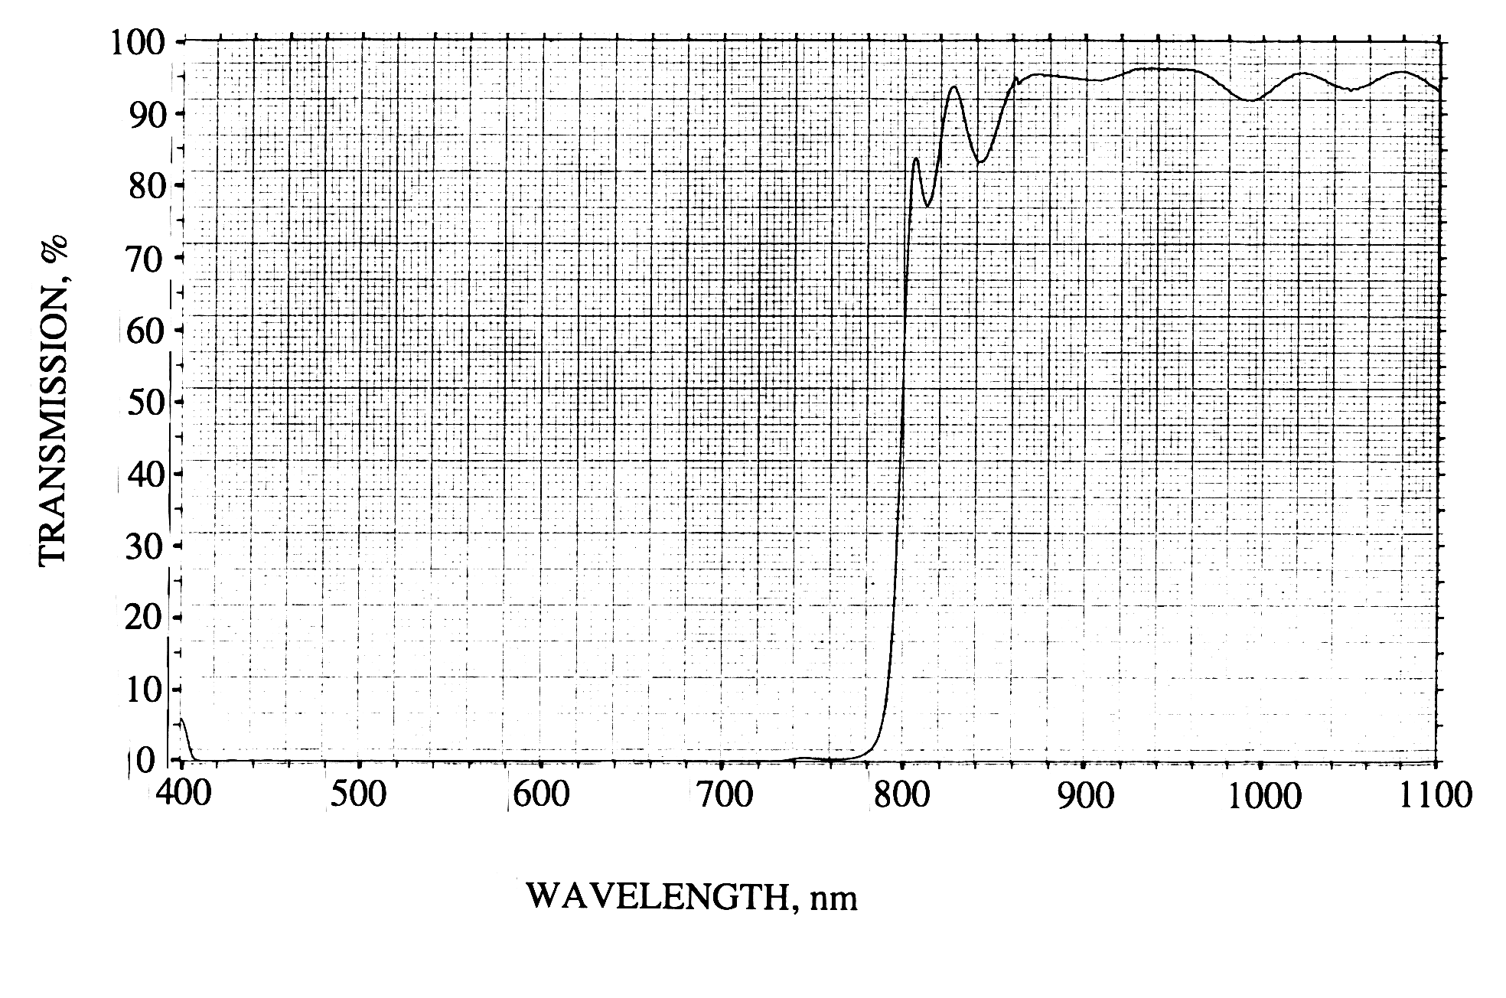
Figure 4.27

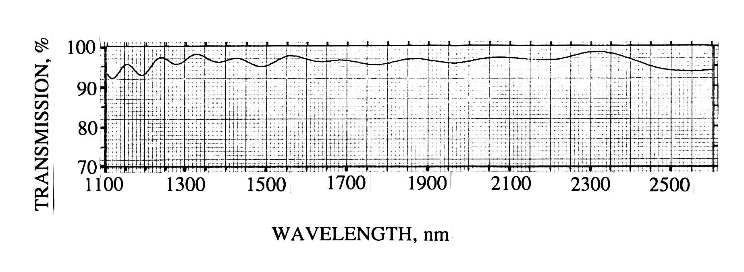
Figure 4.28

How does OIWFS get photons?
With the baseline beamsplitter in Altair, light from 400 to 835 nanometres goes to the AOWFS and longer wavelengths are sent to the science instrument. There is no problem feeding the OIWFS on the Near-Infrared Imager (NIRI) and the Near-Infrared Spectrograph. Both have similar OIWFS schemes -- inside the instrument, the science path is folded by a narrow-field mirror. For example, this is 20 arcsec diameter in NIRI, when at its highest resolution mode for AO. An annular beam outside this science field, goes straight past the mirror, and J and H band photons reach the OIWFS with its infrared detector.

However, some readers have wondered how one might accomplish the I band astronomy outlined in the GAOS Operational Concepts, if the visible light is diverted to the AOWFS. As the OCDD makes clear, the 835 nm cutoff in the baseline beamsplitter is designed to do astronomy with the calcium triplet and pass enough of the continum shortward of this triplet.

The Gemini Multi-Object Spectrograph (GMOS) uses a "dental mirror" probe arm to feed its OIWFS. At the time of the GMOS critical design review, this OIWFS had a notional R band (600 to 800 nm) filter to restrict blurring due to atmospheric dispersion. If so, GMOS OIWFS would have been unable to detect flexure on behalf of Altair.

Subsequent discussions between the GMOS and Altair teams at NRC, have resolved the issue. The filter in the GMOS OIWFS will extend to 900 nm. Thus, when operating with Altair, the OIWFS will get light from 835 to 900 nm. As Appendix 5.6 of the Altair PDR document shows, the product of CCD efficiency and typical stellar emission has sufficient light in this band to sense differential flexure between Altair and GMOS since OIWFS integration times are expected to be on the order of tens of seconds.

