JET PROPULSION LABORATORY

TO: EXAOC

FROM: J. Kent Wallace

Date: August 2, 2004

RE: Extreme AO Wave Front Calibration System

Version: Initial Release

- Introduction

This paper describes the current strawman design for wave front calibration on the extreme adaptive optics coronagraph project. The purpose of the calibration system is to measure the static and dynamic wave front errors between the active wave front sensor (used for closed-loop correction of atmospheric turbulence) and the science camera. These consist of two distinct modes: calibration and maintenance. The calibration routine occurs during periods when the system is not being used for science observations. In this mode, a stimulus is used which simulates the f/# and pupil stop of the telescope. Our favored implementation of the calibration is shown below:

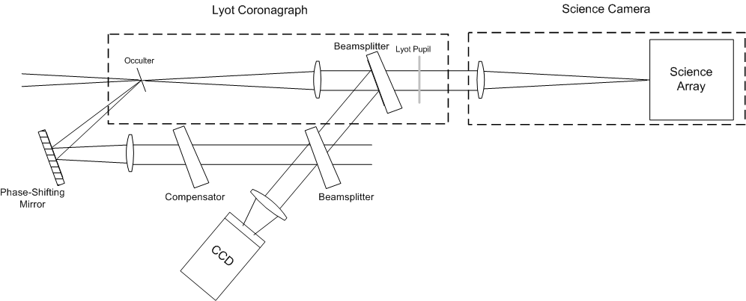Fig. 1 Hybrid technique for measuring post-coronagraph errors using pre-coronagraph photons for the reference generation.

- Calibration Concept

The goal of the calibration is to measure the wave front error in the science arm of the instrument. In our case, this measurement is done via interference with a reference wave front. The reference is generated from the light that would otherwise be rejected from the occulting mask. (Here, no reference is made to a particular coronagraph design (shapted pupil, classic Lyot, nulling coronagraph). This light is spatially filtered and then interfered with some light (~20%, spectrally neutral) in the science arm. Phase-shifting interferometry allows us to estimate both the amplitude and phase of the wave front in the science arm.

There are potentially three different modes in which we can use this method of calibration: initial calibration, semi-real-time calibration maintenance, and PSF knowledge. The final implementation has yet to be designed and depends upon the result of further analysis and simulation.

- Initial Calibration:
Before a science observation, and using an internal source that simulates the telescope f/#, pupil and image planes, the wave front at the science camera is optimized. (The exact method for measuring the wave front on the science camera has yet to be specified, but we assume a method such as focal diversity is sufficient.) The centroid offsets to the active wave front sensor are updated until the science wave front is deemed sufficient. Once this wave front has been optimized, the calibration wave front sensor, briefly described above, measures the initial wave front. This will be used as the calibration wave front set point during a science observation. As such, the wave front as measured by the calibration wave front sensor becomes the proxy for the science camera wave front. It is assumed that the residual non-common path errors that extend from the science pick-off dichroic up to the science camera focal plane are 1) minimized and 2) static.

- Calibration Maintenance
During a science observation, the calibration wave front sensor is under continual operation. It is constantly taking measurements of the wave front at a rate that we have yet to decide. Ideally, the measurement would occur on time scales that allow a wave front measurement limited only by the photon shot noise limit. If it were possible to acquire this knowledge at the update rate of the active wave front sensor, than centroid offsets could be sent to the active wave front sensor continuously, and the calibration would be done continuously. The process is currently under simulation.

- PSF Knowledge and subtraction
If we are unable to apply the corrections in real time, the possibility exist of using the measured estimate of the PSF as knowledge that can be used in post processing of the data. By acquiring and storing the wave front amplitude and phase with the calibration wave front sensor, it’s possible to create an instantaneous PSF via FFT. The PSF’s can be co-added and form an estimate of the residual PSF that can then be subtracted from the science camera image.

- System Interactions
A. EXAO Instrument Stimulus:
We assume the existence of a stimulus which serves as an optical simulator of the Gemini telescope. Ideally, the stimulus provides as an input to the extreme AO system a matching pupil location, pupil size and image plane location (the f/# matches by default). The stimulus also allows one to select the single mode source (thermal or laser) as well as source brightness, and (for the case of the thermal source) a host of selectable calibration filter or band pass filters.

B. Science Camera
This interaction can be minimal or totally subsumed by calibration procedure. The calibration wave front sensor needs to know when the science camera wave front is happy. It can simply be informed when this occurs, or the calibration procedure can be responsible for ensuring this state of wave front bliss (via focus diversity for example).

The calibration wave front sensor also needs to extract from the science path some fraction of light (~20%, spectrally neutral) for the wave front measurement.

C. Active Wave Front Sensor
We assume the calibration wave front sensor has the ability to command centroid offsets to the active wave front sensor.

D. Coronagraph
We assume the calibration system has access to the low spatially frequency component of the light that is typically blocked by an occulting mask of some type. This light is used to create the reference wave front in our calibration interferometer.

- References
  - Colucci, D., Atmospheric wavefront sensing and correction including the stellar phase shifting interferometer, Ph. D. Thesis, University of Arizona, 1993.
  - K. Creath, ‘‘Phase-measurement interferometry techniques,’’ in Progress in Optics XXVI, E. Wolf, ed. (Elsevier, New York, 1988), Chap. 5.
  - Angel, J.R.P., Ground-based imaging of extrasolar planets using adaptive optics, Nature, 368, 203-207 (1994).

