EXAOC

James Larkin July 30, 2004

Integral Field Spectrograph 01.00
Strawman Design Parameters

- INTRODUCTION

This document describes the basic relationships between the lenslet and spectrograph properties for an integral field spectrograph optimized for the EXAOC project. I will assume that the integral field spectrograph is based on the use of a lenslet array. A lenslet based spectrograph has an important advantage over other IFU formats for an EXAO instrument. It is one of the only techniques that samples the image plane early in the optical path. By separating different field points prior to the spectrograph, only the optics in front of the lenslet, typically simple reimaging optics, can degrade Strehl ratio or scatter light. Any errors in these optics will be common to all wavelength channels, giving a high level of speckle suppression.
Spectrograph
Detector
Lenslet
Array
Collimator Optics
Grating
Camera Optics
Focal
Plane
Pupil
Plane
Coron.
Focus
Cold
Lyot Stop
Filters
R. I. Collimator
R.I. Camera
Reimaging Optics
Lenslet

I assume that the lenslet array will follow a cryogenic pupil stop and will sit in a focal plane formed either directly by the AO system or reimaged by additional optics. In the cartoon above, a complete reimaging system is shown with a separate collimator and camera, but this is not assumed as essential to the discussion below. Other options are possible and it may prove ideal to better integrate the AO/Coronagraph with the spectrograph. Placed in a focal plane, each lens in the lenslet concentrates the light into a small pupil image located one focal length behind the array. So the field is broken into an array of well separated spots that form the input aperture to a traditional spectrograph. By rotating the dispersion axis of the spectrograph compared to the orientation of the lenslet array, the spectra can be made to interleave between each other and not directly overlap. In this way, spectra distributed over a rectangular field of view can share the same detector.

- LEVEL 1 REQUIREMENTS

This section describes the absolute minimum requirements that the strawman must demonstrate to be scientifically viable as the main scientific instrument for the EXAO system.

  - Minimum wavelength range of 1.15 to 2.4 microns.

  - Spatial sampling smaller than the Nyquist condition at a wavelength of 1.6 microns for the Gemini 8 meter telescope. This corresponds to 0.025’’ sampling.

  - A minimum field diameter of 2 arcseconds. This, combined with requirement 2.2, requires at least 80 spatial samplings on a side.

  - Spectral resolution greater than 30.

  - Wavefront Error less than 50 nm.

  - Spatial samplings should be separated by at least 2 pixels on the detector.

  - Spatial distortion from center to field corners is less than 1%.

  - The chromatic variation in plate scale should be less than 2% across the wavelength range.

- OPTICAL RELATIONSHIPS

  - Variable Definitions

λ = Focal length of interest in microns
D = Telescope Diameter in microns
T = Telescope effective paraxial focal length at the lenslet array in microns
F = Effective paraxial focal ratio at the lenslet array ( F = T/D)
θ_{Diff} = Diffraction limited angular resolution

l = Lenslet array pitch in microns
f = Lenslet focal length in microns
Ψ= Lenslet focal ratio (Ψ=f/l)
θ = Angular sampling of the lenslet array in radians on the sky
d = Geometric pupil diameter produced by the lenslet in microns
z = Actual pupil diameter including aberrations
s = Sampling ratio of the lenslet compared to the diffraction limit. s=2 implies Nyquist sampling.

q = Detector pixel pitch in microns
L = Length of each spectrum in pixels
w = Center-to-center spacing of neighboring spectra perpendicular to the dispersion axis in pixels
F = Focal ratio at the detector
A= Detector array width in pixels (e.g. 2048)
P = Lenslet rotation pattern in lenslets. Since the lenslet array must be rotated compared to the dispersion axis, each spectrum will eventually run into one from the row above or below, but this lenslet will be staggered over by P lenslets.
R = Spectral resolution (Δλ/λ)
B = Spectral bandwidth of each full spectrum (Δλ/λ)
N= Number of spatial samples along each axis
V= One dimensional field of view

  - Lenslet Sampling

The angular scale (θ) of the lenslets on the sky is set very simply by the focal length of the telescope (T) and the pitch of the lenslets (l):

$θ=\frac{l}{T}$ in Radians
The angular diffraction limit is also a simple relationship:

$$θ_{\text{Diff}}=\frac{1\text{.}\text{22}⋅λ}{D}\text{ in Radians}$$
I define the spatial sampling (s) as the ratio of the diffraction limit divided by the angular size of the lenslets:
$$s=\frac{θ_{\text{Diff}}}{θ}=\frac{1\text{.}\text{22}⋅λ⋅F}{l}$$

  - Spot Size

A key parameter in the instrument design is the size of the pupil spots formed by each lenslet array. The geometrical size of the spot (d) neglecting diffraction and aberrations is given by the ratio of the lenslet focal length (f) and the effective focal ratio of the telescope at the lenslet (F):
$$d=\frac{f}{F}$$
But due to the small sampling of the Airy pattern, the pupil image formed by each lenslet is aberrated causing the actual pupil diameter to be larger than the geometric pupil. This becomes very pronounced as the sampling factor increases.

    - Zemax modeling of pupil aberration

To try and better model the impact of subsampling the Airy pattern with the lenslet array, I created a simple optical model using paraxial optics and the physical optics propagation (POP) routines with zemax. The telescope was modeled as an 8 meter diameter circular aperture with a 1.5 meter diameter central obscuration. As a paraxial optic, I gave it a focal length of 800 meters for a focal ratio at the lenslet array of F/100. A second paraxial optic was placed in the F/100 focal plane to serve as the lenslet array. This second optic was given a focal length of 3.08 mm, and had a variable square aperture. It produces a pupil image at the last surface of the model. For the POP model, a uniform illumination of 12 meter diameter was fed into the telescope and a 1024x1024 image sampling grid. The output irradiance is calculated and presented below as a function of lenslet size (rectangular length and width). All calculations are done at a wavelength of 1.6 microns which for an 8 meter telescope produces an Airy radius of 195 microns. All images below are shown at the same magnification.

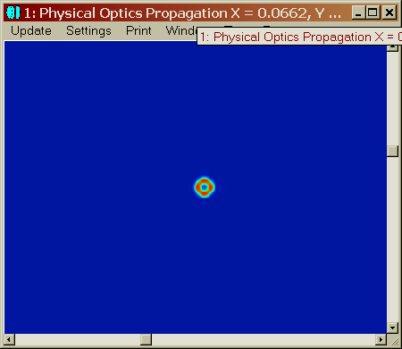
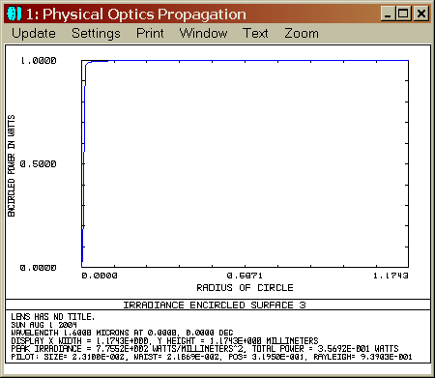
As a start, the lenslet diameter was set at 3 times the Airy radius or 585 microns across. As the images above show, diffraction plays essentially no role in the pupil image which has the geometric diameter of 30 microns.
Above are the pupils produced by a lenslet element with a angular sampling of 3x the Airy pattern. The outer diameter is very close to the 30 micron diameter predicted by simple geometric optics implying that diffraction does not significantly affect the pupil diameter. The encircled energy is shown as a function of radius in the right panel. The FWHM is 19 microns with 90% of the energy enclosed within 27 microns.

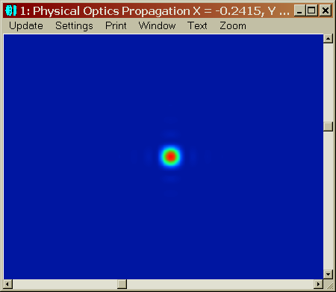
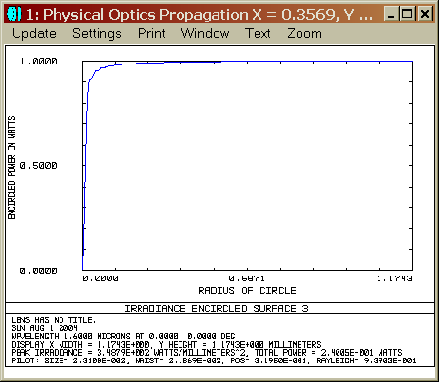
Next, the lenslet was set to a width equal to the Airy radius (0.05”):

Above are the pupils produced by a lenslet element with a angular sampling of 1x the Airy pattern (0.05” sampling, s=1). The diameter of the green colored isophots are still close to the 30 micron geometric diameter, but there is clearly a square halo of a first null of width 50 microns, and additional ringing at larger separations. The panel on the right shows the encircled energy as a function of radius. The FWHM is 23 microns and 90% of the energy is within a diameter of 48 microns.

Then the lenslet was set to Nyquist sample the focal plane (0.025” sampling):
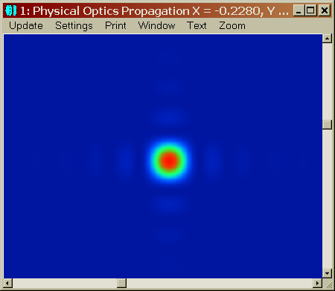
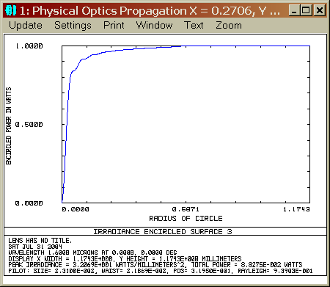
Above are the pupils produced by a lenslet element with a angular sampling of ½ of the Airy pattern (Nyquist sampling of a stellar image, s=2). The FWHM of the pupil spot is 48 microns, but the 90% encircled energy doesn’t occur until a diameter of 174 microns.

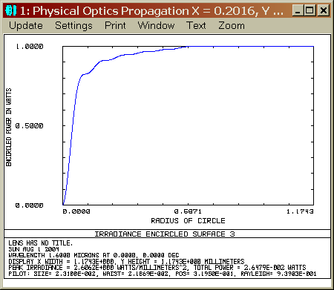
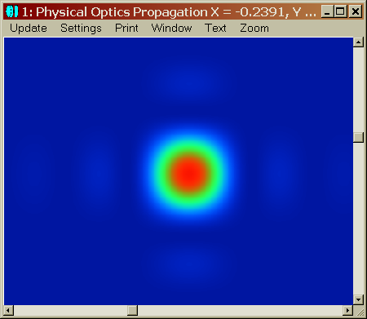
Then the lenslet was set to twice as fine as Nyquist sampling (0.0125” sampling, 4 lenslets per PSF).

Above are the pupils produced by a lenslet element with a angular sampling of ¼ of the Airy radius (twice Nyquist sampling of a stellar image, s=4). The FWHM is 95 microns and 90% of the light is enclosed in a diameter of 344 microns.

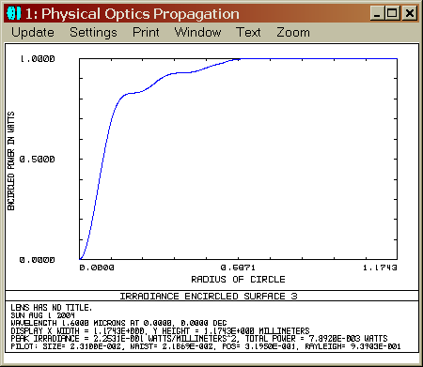
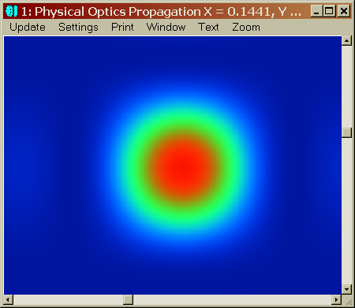
Finally the lenslet was set to 1/8th of the FWHM of a diffraction limited star (0.00625”)

Above are the pupils produced by a lenslet element with a angular sampling of 1/8 of the Airy pattern (four times finer than Nyquist sampling of a stellar image, s=8). The FWHM is now 176 microns with 90% of the energy enclosed in a diameter of 602 microns. This is substantially larger than the expected lenslet diameter!

    - Aberrated Spot diameters

As shown in section 3.3.1, the actual pupil spots produced by the lenslets can be substantially larger than the geometric diameter. Since our level 1 requirements include at least Nyquist sampling, we only need to discuss the aberrated pupil sizes. Although the physical size of the spot depends on the lenslet properties and the wavelength, everything can be scaled to the sampling ratio (s). Looking at the examples above with at least Nyquist sampling, the FWHM of the spots is always within a few percent of the expression below:

$$z(\text{FWHM})≈0\text{.}\text{75}⋅s⋅d=\frac{0\text{.}\text{75}⋅s⋅f}{F}=0\text{.}9⋅λ⋅ψ$$
Likewise the diameter at which 90% of the energy is enclosed is within a few percent of:

$$z(\text{90}\text{\%})≈2\text{.}9⋅s⋅d=\frac{2\text{.}9⋅s⋅f}{F}=3\text{.}5⋅λ⋅ψ$$
Ideally, all of the light from each spot would be contained in a single spectrum without overlapping any other spectrum. This cannot be achieved in reality so we must instead try and decide what level of contamination is tolerable. Since algorithms have been developed for OSIRIS to extract overlapping spectra, and since neighboring lenslets are from neighboring spatial samples, and because they sub-sample the image plane, I will assert that something like 5% contamination will have a negligible impact on the scientific capability. This is more than satisfied by setting the spacing of adjacent spectra (w in detector pixels) at the 90% encircled diameter (z(90%)) mapped to the detector. It is also necessary for the FWHM to be mapped to roughly 1 pixel so that pupil diameter won’t degrade spectral resolution.

A pixel mapping that satisfies both the spectral resolution requirement and the encircled energy requirement is 3 pixels dedicated to holding the 90% encircled energy, and a spectral spacing of 3 pixels (w=3)..

So the magnification of the spectrograph from the lenslet spot to the detector is set by the ratio of lenslet focal ratio (which must match the spectrograph collimator focal ratio) to the detector focal ratio and must perform this mapping:
$$\frac{z(\text{90}\text{\%})}{3⋅q}=\frac{ψ}{F}\text{ which becomes }F=\frac{q}{1\text{.}2⋅λ}$$
This has a direct effect on the instrument design. The longer the operational wavelength, the faster the spectrograph camera needs to be. Also, smaller detector pixels force a faster camera. Given a pixel scale of 18 microns (Hawaii-2), and a longest wavelength of 2.4, this forces the camera to be at least 6.25. This is manageable, but slightly faster than the OSIRIS camera. Also note that this is the paraxial focal ratio. If the lenslets are square, then the camera would be 1.414 times faster or F/4.4 to the corners.

  - Spectral Format

Each spectrum will have a length in pixels L, and a width or spacing of w (as discussed above, probably 3 pixels). This essentially means that each pupil has L.w pixels assigned to it, and this sets the maximum field of view. The length of the spectrum is determined by the desired resolution (R) and the spectral bandwidth. With the spot mapping above, the spectral FWHM should be 2 pixels or less. So the length can be approximated by:
$$L=2⋅B⋅R$$
So each lenslet’s spectrum is mapped to L.w pixels out of a possible A.A pixels. So the number of spatial pixels can be no more than:
$$S=\frac{A}{\sqrt{L⋅w}}=\frac{A}{\sqrt{6⋅R⋅B}}$$
The field of view is then given by:
$$V=S⋅θ=\frac{A⋅θ}{\sqrt{6⋅R⋅B}}$$

- STRAWMAN SYSTEM

A spreadsheet was created that reflects all of the equations above as well as calculating lenslet array rotation angles the pattern parameter. In this section I’ll use this spreadsheet to determine possible parameters for a strawman spectrograph.

Parameters that are likely to remain fixed are the detector size of 2048x2048 with 18 micron pixels (Hawaii-2), although an alternative long wavelength IFU might use an Aladdin array with 27 micron pixels and a 1024x1024 format. It is also likely that a spectral spacing (w) of 3 pixels will be used with an optical demagnification in the spectrograph placing one pupil FWHM at around one pixel on the detector.

Since the longest wavelength sets the focal ratio at the detector, for this version, I’ve limited the wavelength range to 2.4 microns which makes the camera f/#=6.25. The shortest wavelength sets the platescale which controls many aspects of the instrument. I’ve elected to make the shortest wavelength 1.2 microns and have a plate scale that Nyquist samples the 1.2 micron diffraction limit (sampling = 0.0189”/lenslet).

The most flexible parameters are the spectral resolution and lenslet pitch. A higher resolution makes the lenslets faster since you must compress the pupils more to interleave them. It also reduces the field of view. A larger lenslet pitch allows the lenslets to be slower, but for the same field of view the field angle becomes larger. For the strawman, I’ll assume a spectral resolution of 50 and pick a corresponding lenslet array with a focal ratio no faster than F/3.1 (OSIRIS’s lenslet speed). I’ve also set the bandwidth per exposure to 20% to make sure we cover a full broadband in each exposure.

The table below gives the final values for a strawman meeting all level 1 requirements and consistent with the discussion above.

Parameter | Value
Telescope Diameter | 8 meters
Focal ratio at the lenslets | F/123
Lenslet Pitch | 90 micron squares
Spectral Resolution | 50
Plate scale | 0.0189 arcsec
Field of View | 5.8 x 5.8 arcsec
Total wavelength range | 1.2-2.4 microns
Bandwidth per exposure | 20 % (Full broad band)

The output data cube would consist of 20 spectral images, each with 307x307 spatial pixels.

